The reflective statement

The role in my team, A14 was varied and yet revolved in one area. My focus on graphs and manipulating data, so data visualisation. My first task was to understand the different types of graphs that are required for the data and finding out about the diverse variable and their connotations with each other.

The main ones that I looked at were:

* Histograms

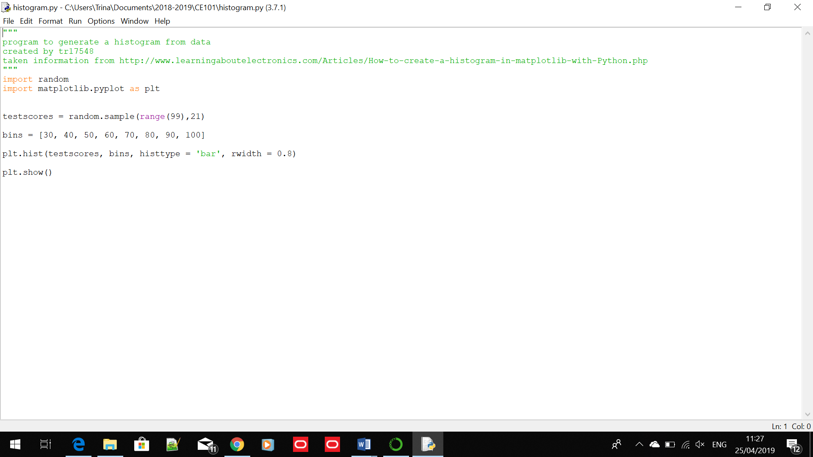

* Scatter plot
* Box plot

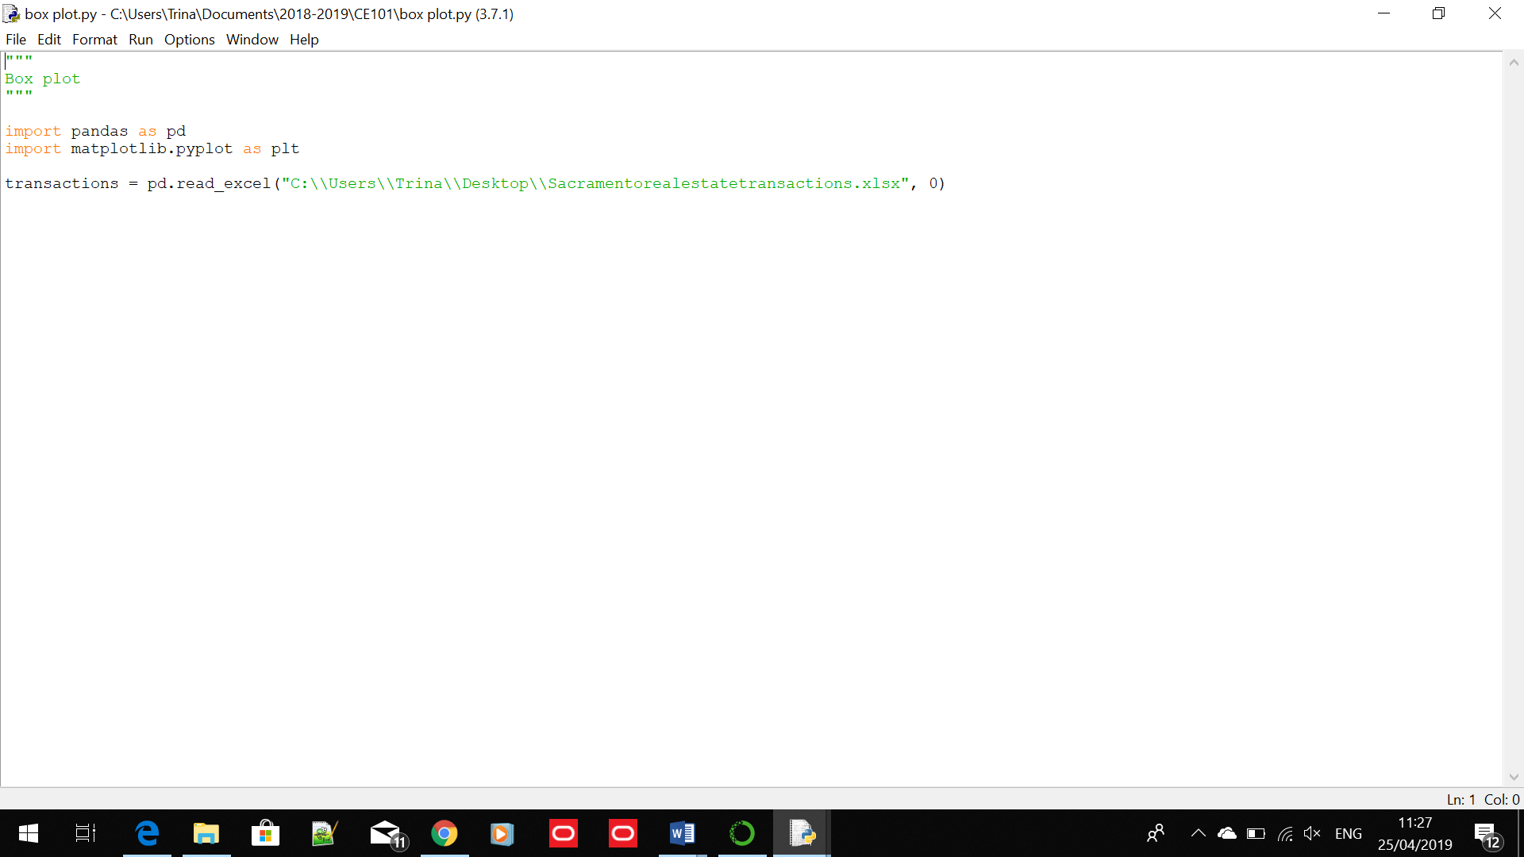

* Bar chart
* Correlation

The pictures above are some of the code that I used as inspiration for our project. They were the first draft. The product at this point, is not the best, because were falling behind schedule, I sent them a copy of what I had at that point.

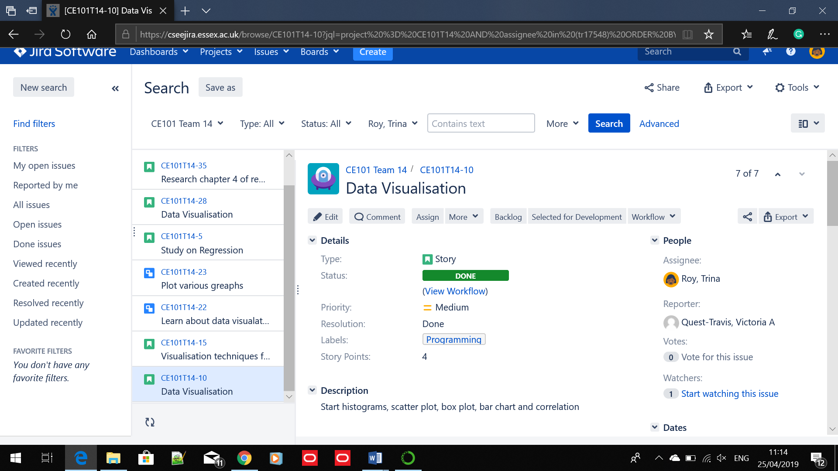

This is the first task that I was assigned

We, as a team were not sure of what we were supposed to do most of the time, and because of that, our team performance was not the best.

Most of the time, some team members would not update their task on Jira, because they were not familiar with it, and would affect the overall rating of our team.

If I were to talk about my own performance in the team, I would say I could have done much better, such as improve the code I had for every graph, so it would be more accurate, even though my role in the team is not the biggest, because we switched to a neural network, and I had no idea of what a neural network was, but the other members would help me understand what was going on.

Our team worked well, in my opinion. There were not many disagreements on the tasks set out. But one team member, would never turn up on the set team meetings, would never do the tasks set on Jira and because of that, the other team members would have more work to do to cover the said team member.

For me, we delivered decently and on time. The quality, though did suffer because we were disorganised at the beginning.

The presentation went smoothly. I don’t have any complaints, though I could have a bit more confident and less petrified of the situation.

There are lots of things that I learned:

Team work is an essential skill in the workplace, and it’s very important that you are a very open-minded person and can manage people’s feelings well.

I learned what is a neural network and how to generate different types of graphs in python.

I found the response appropriate to our product.